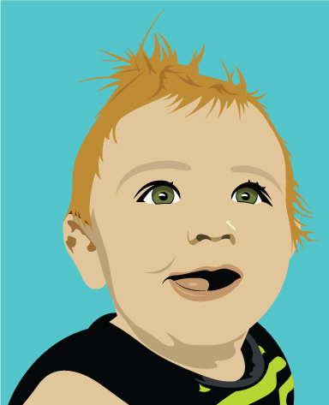
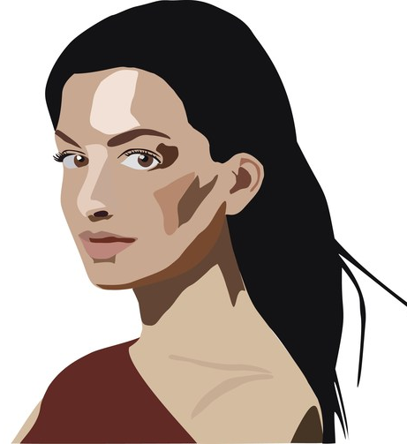
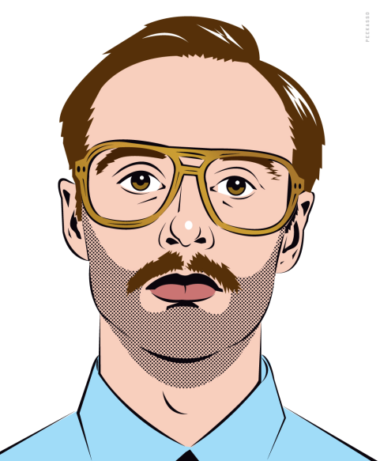
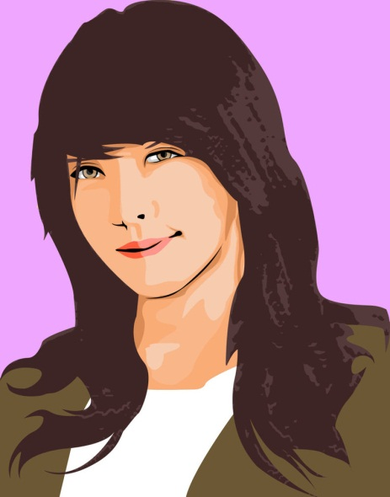
Vector Portrait in Illustrator

Description

You will be using Adobe Illustrator to create a vector self-portrait..

Your Assignment
Have a high quality picture taken of you. Using the Pen Tool and Shape tools create the basic shape of the face. You will probably need to use the Direct Selection Tool to manipulate points within the shapes you create to better match it to your picture. Use the Color Palette to apply color to your shapes that best match your picture. You will probably need to make highlights using tints and shades of your colors. The style of your portrait doesn’t have to match the examples, but needs to present a refined, finished piece that demonstrates your understanding of the tools in Illustrator. Include a background for the finished portrait. This background could be simple or complex, but keep in mind that it should match the style you’ve chosen for your portrait.

Technical Specifications
- Open the picture you’ve chosen for your portrait in Adobe Illustrator. Choose an 8.5x11 inch artboard, either in orientation, landscape or portrait
- Must use multiple shapes and colors to portray your finished portrait
- Once completed save as an Adobe Illustrator file (.ai) firstname_lastname_vectorportrait.ai

Objective
- Using Adobe Illustrator create a Vector Portrait. Utilize the pen tool, shape tools, direct selection tool, and color palettes at the very least.

References
- http://vector.tutsplus.com/tutorials/illustration/tracing-a-vector-face-from-a-reference-photo/
- http://vector.tutsplus.com/tutorials/illustration/how-to-create-a-simple-vector-avatar-from-a-stock-image/
- http://vector.tutsplus.com/tutorials/illustration/turning-a-photo-into-lichtenstein-style-pop-art-with-illustrator/
- http://vector.tutsplus.com/tutorials/illustration/how-to-create-a-self-portrait-in-a-geometric-style/
- http://blog.spoongraphics.co.uk/tutorials/how-to-create-a-beautiful-vector-portrait-in-illustrator)

