Illustrator Age Chalkboard Project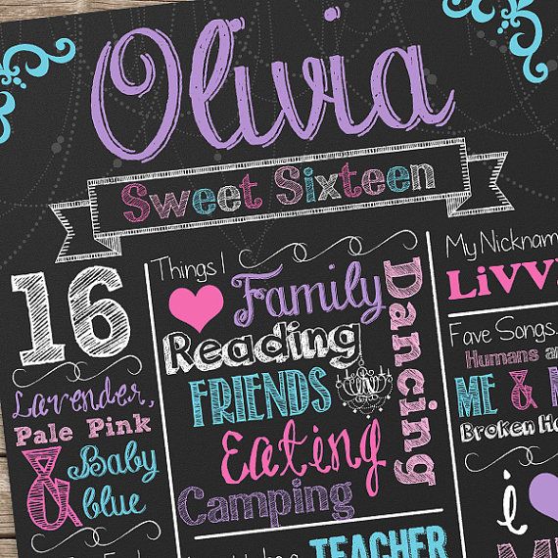

First, grab a chalkboard background. This site provides an AI file in landscape (you can change your Artboard to portrait and rotate the image, if needed). Wall stone background vector download--
http://www.freepik.com/free-vector/wall-stone-background_713978.htm

Next, find some useful “chalkboard” vectors:
http://all-free-download.com/free-vector/chalkboard_page_1.html

And perhaps some dingbat fonts you can use for symbols:
http://www.dafont.com/nymphette.font (Nymphette font)
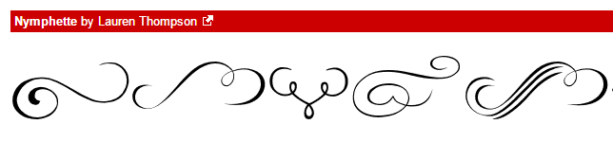
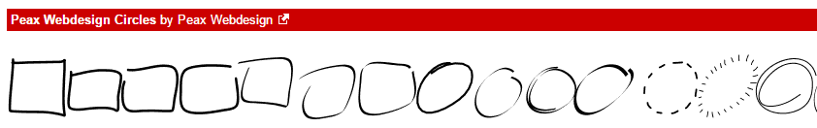
http://www.dafont.com/theme.php?cat=710 (Dingbat> Shapes category)

Some great font sets that include “dingbat” symbol fonts are by this illustrator:
http://www.fontspace.com/kimberly-geswein (also lots of chalkboard fonts)
For example, here is the “map” for KG Flavor and Frames Six:
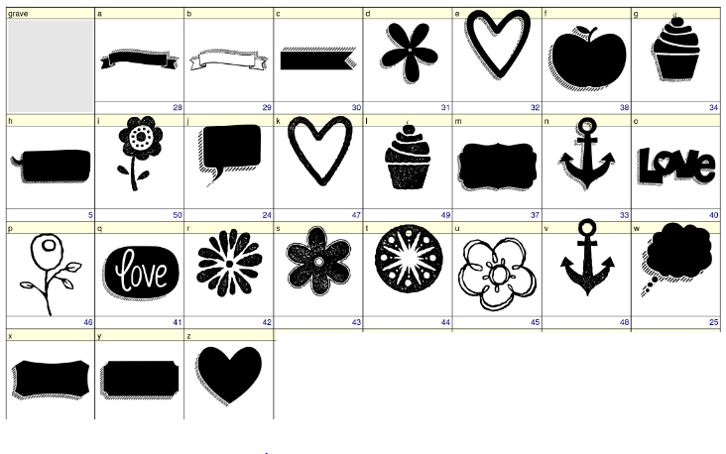
Another great font creator with some handwritten fonts:
http://www.dafont.com/darcy-baldwin.d1819
http://www.dafont.com/tina-r.d1874
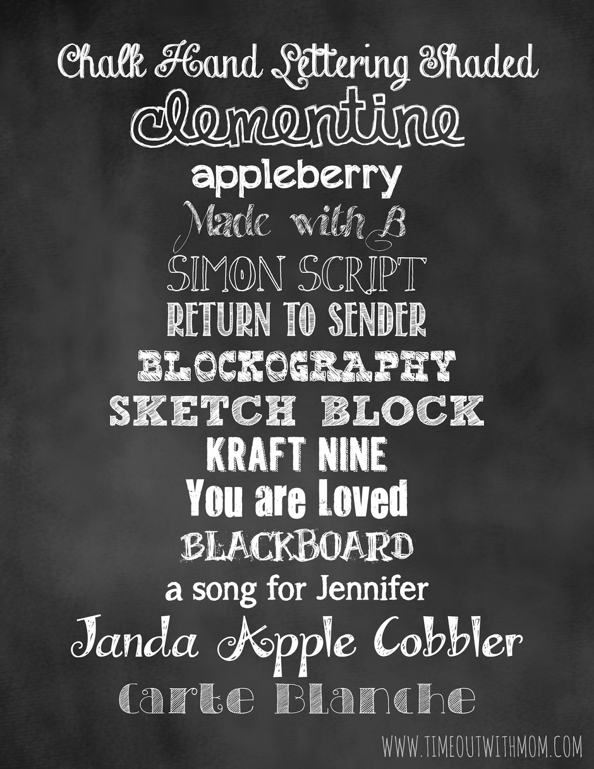
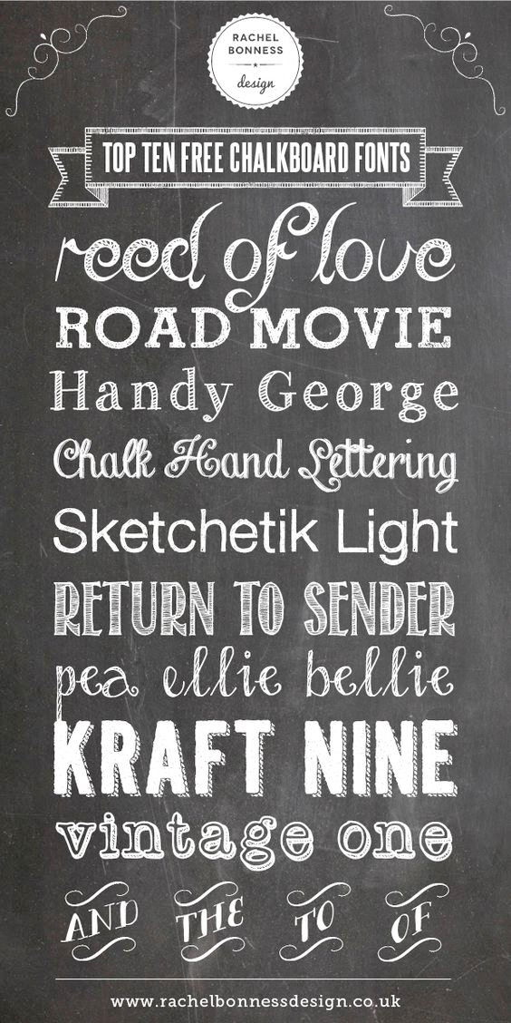
You can download any of these fonts at dafont.com for your project.

And this site has some cool Illustrator brush sets:
http://www.melsbrushes.co.uk/free-illustrator-brushes-2/

So, before you begin, install your fonts, gather all your sketches and doodles, and then you are ready to get into Illustrator and start creating!

SCORING GUIDE
Illustrator “Age Chalkboard” Project

Category | Criteria | Points Possible | Deductions
Design Principles | Utilizes only a few colors, contrast, proximity/like elements grouped into divisions, and design looks attractive to the eye. | 10
Vector Art | Design incorporates at least one “special brush” applied as a stroke (dashed, dotted, rough, etc.), at least 4 vector objects (dingbat fonts or AI vectors), and artwork seems to go well together. | 10
Typography | Creative use of various sizes of fonts and at least 5 fonts on the page that include some script/handwritten and some display (large/heavy) fonts. Fonts contribute to the “chalkboard” feel of the project. | 20
Professionalism | Project submitted properly (Save as PDF and upload to Canvas) by due date with no spelling or grammar errors and is “print quality” and suitable for client distribution. Final layout is high quality and could be reused as a template. | 10
TOTAL POINTS |  | 50

Examples from online:
